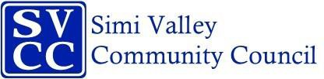

# Annual President’s Breakfast – June 7, 2025

# Community Service Honoree Submission deadline is May 23th

Email the form to [simivalleycommunitycouncil@gmail.com](mailto:simivalleycommunitycouncil@gmail.com)

Please complete the information below:

|  |  |  |
| --- | --- | --- |
| *Name of Honoree:* |  | |
| *Submitted by* | *Your Name:* |  |
| *Your Organization:* |  |
| *Your Email Address:* |  |
| *Your Phone Number:* |  |

In 125 words (Maximum) or less, please type below why you are honoring this person. This description will be the SCRIPT for the presentation. Descriptions exceeding the 125 word limit may be edited. **Also include a jpeg picture of the nominee.**