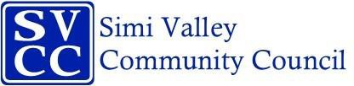

Annual President’s Breakfast – June 13, 2026

Community Service Honoree Submission deadline is May 15th
Email the form to simivalleycommunitycouncil@gmail.com

Please complete the information below:
Name of Honoree:
Submitted by | Your Name:
Submitted by | Your Organization:
Submitted by | Your Email Address:
Submitted by | Your Phone Number:

In 125 words (Maximum) or less, please type below why you are honoring this person. This description will be the SCRIPT for the presentation. Descriptions exceeding the 125 word limit may be edited. Also include a jpeg picture of the nominee.

